COVER PAGE.

Module: Web Development (Introduction) WEDE5020.

Full name: Armand Schutte Rieck.

Student Number: ST10507392

WEDE5020 POE: Part 1 – Planning webpage for Direct-Link Africa, Non-Profit Organization.

Choose a Target Organisation:
- DirectLink Africa: Non-Profit Organisation, distributing item donations for North and West Africa.

Research and Planning:
- Project Proposal: Direct-Link Africa.

- Organisation Overview:
- Name: Direct-Link Africa (Non-Profit Organisation)

- Description of organisation: Direct-Link Africa was created to solve key issues in the donations of humanitarian aid. A non-profit logistics organization created to replace cash drives with item pledging, while being transparent giving from all around the world directly to Northern and Sub-Saharan Africa.

- Mission: Link donors with regional shortages.

- Vision: Creating a world where donated goods match up with the needs of the community.

- Target I hope to impact: Direct-Link Africa wants to impact Gen-Z and Millennials that want to give back as well as community-based partners (church groups, corporate teams).

Website Goals and Objectives:

- Goals: The Goal would be to build a website to help those in need, coming across people who can help or want to help the less fortunate communities.

- Key Performance Indicators: Measure the impact by tracking visitor behaviour and finding the best landing page performance. According to CauseVox (2026), for to consider a cause effective in terms of engagement, you need to have a system of visitor behavioural tracking that allows you to measure success by landing page success rates. The tracking software that should combine actual identification of donor profile along with the accurate measurement of the location and status of inventory, that the most non-profit warehouses serve only as distribution hubs, passing product across directly to the intended recipient programs (NetSuite, 2026).

Proposed Website Features and Functionality:
- Homepage:
- The home page will have a Hero image with a short motivation on why donations are needed, at the right corner of the homepage would be the about us, contact page, and services page.
- About us:
- The about us page will explain the mission we have with the donations that get sent to Direct-Link Africa, explaining in detail what they will be doing and the impact each donation will have.
- Contact page:
- The contact page will have an personal details form, email address, queries box, an Address, and a landline number.
- Services: The services page will be where the donation forms are being filled in and where the donations will be made

Design and User Experience:

The overall design of the website would be Nature themed

- Colour Theme:
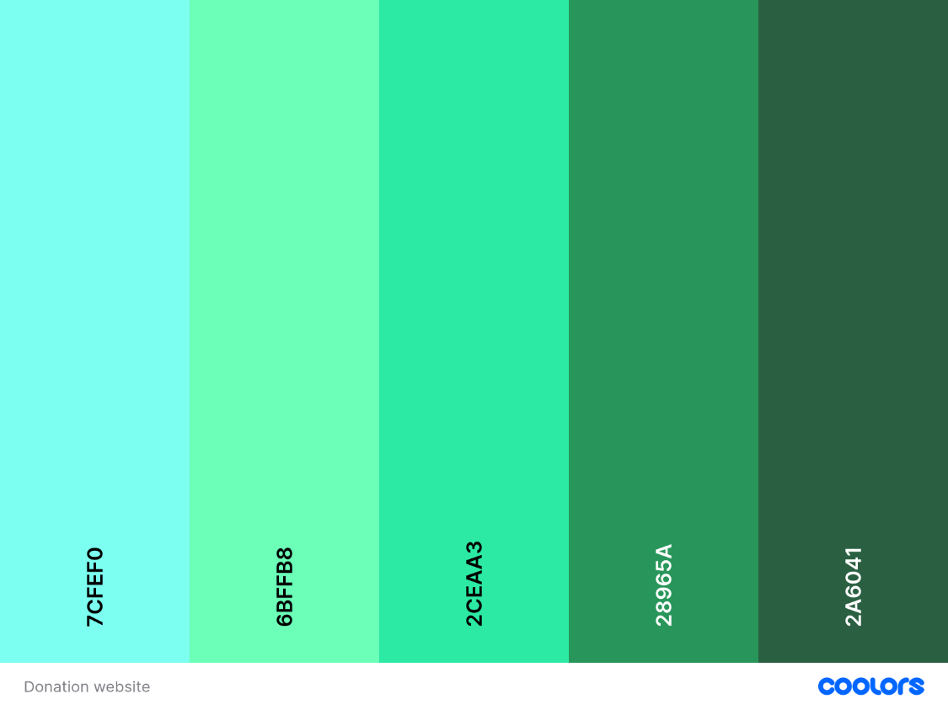
Figure 1

- Typography:
The font that is planned to be used is Sans-Serif with Monospace spacing.
The Hierarchy would consist of the Themed colours shown above, A dark background with Light coloured writing.

- Layout and design:
The layout of the website would be simple and easy to navigate. For the design we will use the above theme template, with some images.

- User experience considerations:
The website must be mobile and PC compatible, Users must find it easy to navigate through the website by keeping it simple but interesting enough to keep them on it

Wireframes:

- Homepage:
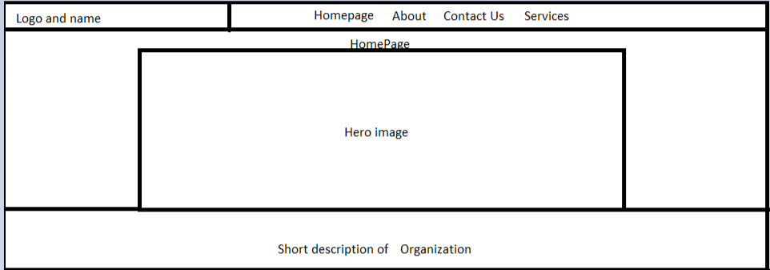

- About:
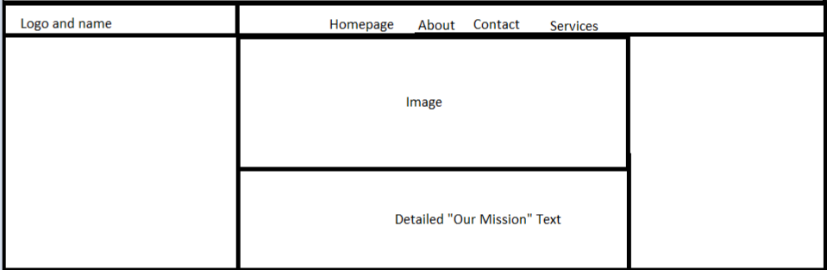
- Contact:
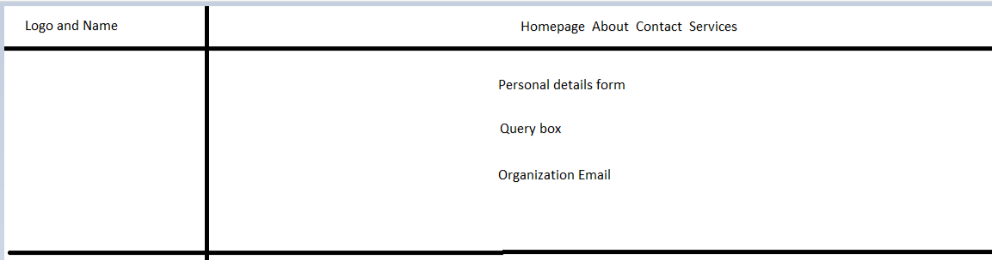

- Services:
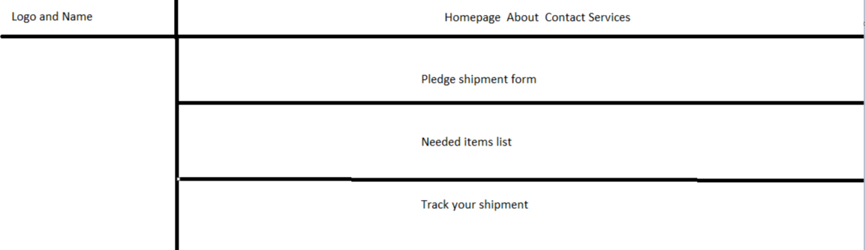

Technical requirements:

- Domain name: www.DirectLinkAfrica.co.za
- Website Host: HostAfrica Link: https://hostafrica.co.za/hosting/web-hosting/
- Programming Languages: HTML, CSS, JavaScript

Timeline and Milestones:

- Time-Period: 6 Months of production
- Month 1-2: Build main structure (HTML)
- Month 3-5: Build style (CSS and JavaScript)
- Month 6: Test website and make sure its in full working order

Budget:

- Production of website: R9000,00 once off
- Keeping website up to date: R700,00 Per month
- Hosting: R1200,00 Yearly
- Domain Name: R150 Yearly

Reference List:
CauseVox, 2026. 6 Donation page KPIs you should be tracking. [online] Available at: https://www.causevox.com/blog/6-donation-page-kpis-you-should-be-tracking/ [Accessed 24 July 2026].

NetSuite, 2026. Nonprofit inventory management explained an expert guide. [online] Available at: https://www.netsuite.com/portal/resource/articles/inventory-management/nonprofit-inventory-management.shtml [Accessed 24 July 2026]

